PRESS RELEASE For Immediate Release.

JERK, SEAFOOD & VEGAN FEST SAY A BIG THANKS TO THE 10,000+ PATRONS WHO ATTENDED LAST WEEKEND JSVFEST AND MADE IT A GREAT SUCCESS!
KEVIN LYTTLE, JACK RADICS, SISTER NANCY & MR. C ROCK THE WEEKEND!

September 2018, Chicago:

Chicago may have seen its worse weather of the season last weekend, but the rainy, chilly and windy weather didn’t stop the 2nd annual Jerk, Seafood and Vegan Fest (JSVFest), hosted by Martin’s International from being a big success.

Music superstars Sister Nancy on Saturday night didn’t allow the cold from delivering a solid performance, and on Sunday Kevin Lyttle, Jack Radics and the creator for the Cha Cha Slide Mr. C, gave the audience some unique and outstanding performances. The weekend saw great performances from some twenty other acts

Kevin Lyttle, Sister Nancy, Jack Radics and Mr. C. (Casper) each received an IRAWMA Special Award of Honor from Ephraim Martin for their extra-ordinary contributions to the music and entertainment industry.

Some four thousand of the ten thousand fans who attended took advantage of the advance $5 and $18 group of 4 tickets to enjoy the real taste of Jerk, Seafood and Vegan cuisine.

At 7:000pm on the first day all Vegan vendors were sold out and by 8:30pm all other food vendor’s inventory were depleted. All the vendors rapidly increased their food supply for the final day to satisfy the demand of the food lovers.

From the opening at noon to close, patrons were coming and going throughout the day purchasing food; as the 60+ degree temperatures and harsh winds prevented them from enjoying the festival for more than a few hours.

The 2018 JSVFest winners were:

Best Jerk Restaurant/Catering – Irie Jerk, Bar and Grill, at 3404 N. Clark Street, phone 872/802-4999, Chicago

Best Seafood Restaurant/Caterer - Lawrence's Fish & Shrimp at 2120 S. Canal Street, Chicago, (312) 225-2113
- Best Vegan Restaurant/Caterer – These Wingz, Chicago; phone (888) 389-4649

The event was sponsored by Chicago Park District, WVON AM, LaFruteria, Inc, Rogers Park Fruit Market, Old World Market, Wallace Funeral Home, African Spectrum, Urban Grind TV, Rasta Love Punch and others

JSVFest thanks all its sponsors, staff, patrons and others for their participation.

We value your comments, suggestions and feedback. Feel free to email us at jsvfestival@gmail.com

Save these dates for 2019:
- 38th Annual Chicago Music Awards (CMA), March 2019. Like @chicagomusicawards
- 37th Annual International Reggae & World Music Awards (IRAWMA), May 11th, Pegasus Hotel, Kingston, Jamaica. Like @irawma
- 27th Annual International Festival of Life (IFOL), Union Park, July 4th - 7th. Like @festoflife

- 3rd Annual Jerk, Seafood & Vegan Fest (JSVFest), Park 540, enter from 2400 South State Street, Chicago South, Sept 7 & 8, 2019. Like @JSVFest -- end –

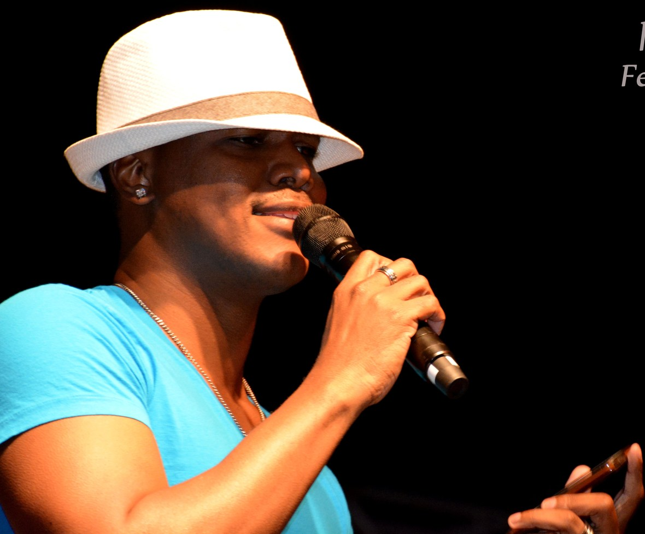
(Kevin Lyttle in action before receving IRAWMA special Award of Honor)
KEVIN LYTTLE, JACK RADICS, SISTER NANCY & MR. C, CHA CHA SLIDE ROCK THE WINDY AND CHILLY WEEKEND!
September 2018, Chicago:
Chicago may have seen its worse weather of the season last weekend, but the rainy, chilly and windy weather didn’t stop the 2nd annual Jerk, Seafood and Vegan Fest (JSVFest), hosted by Martin’s International from being a big success.
Music superstars Sister Nancy on Saturday night didn’t allow the cold from delivering a solid performance, and on Sunday Kevin Lyttle, Jack Radics and the creator for the Cha Cha Slide Mr. C, gave the audience some unique and outstanding performances. The weekend saw great performances from some twenty other acts

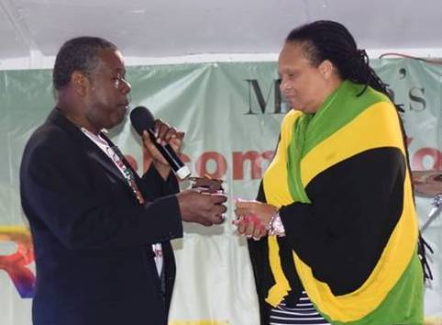
Ephraim Martin presenting IRAWMA Special Award to Sister Nancy @ JSVFest, Chicago

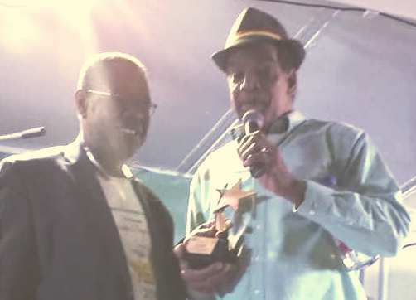
Ephraim Martin presenting IRAWMA Legend Award to Jack Radics @ JSVFest, Chicago

Mr. C- Casper before receiving special IRAWMA award

Kevin Lyttle, Sister Nancy, Jack Radics and Mr. C. (Casper) each received an IRAWMA Special Award of Honor from Ephraim Martin for their extra-ordinary contributions to the music and entertainment industry.

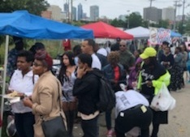
Patrons waiting in the Jerk food line before it was all gone on the 1st day

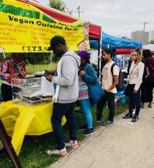
Vegan lovers asking for more as the food ran out on Saturday

At 7:000pm on the first day all Vegan vendors were sold out and by 8:30pm all other food vendor’s inventory were depleted. All the vendors rapidly increased their food supply for the final day to satisfy the demand of the food lovers.
From the opening at noon to close, patrons were coming and going throughout the day purchasing food; as the 60+ degree temperatures and harsh winds prevented them from enjoying the festival for more than a few hours.
The 2018 JSVFest winners were:
- Best Jerk Restaurant/Catering – Irie Jerk, Bar and Grill, at 3404 N. Clark Street, phone 872/802-4999, Chicago
- Best Seafood Restaurant/Caterer - Lawrence's Fish & Shrimp at 2120 S. Canal Street, Chicago, (312) 225-2113
- Best Vegan Restaurant/Caterer – These Wingz, Chicago; phone (888) 389-4649

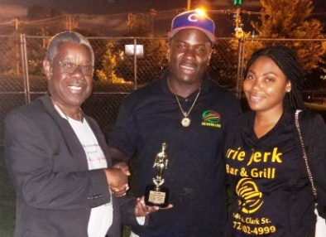
Ephraim presenting Best Jerk Rest/Caterer Award to Irie Jerk Bar & Grill,Kevin G. and wife

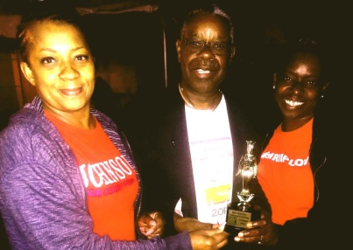
Val and Rolanda reprenting Lawrence's Fish & Shrimp receiving Best Seafood Award from Ephraim

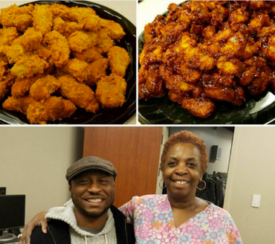
These Wingz captured the JSVfest Award for Best Vegan Rest./Caterer

The event was sponsored by Chicago Park District, WVON AM, LaFruteria, Inc, Rogers Park Fruit Market, Old World Market, Wallace Funeral Home, African Spectrum, Urban Grind TV, Rasta Love Punch and others
JSVFest thanks all its sponsors, staff, patrons and others for their participation.
We value your comments, suggestions and feedback. Feel free to email us at jsvfestival@gmail.com
SAVE THE 2019 DATES BELOW:

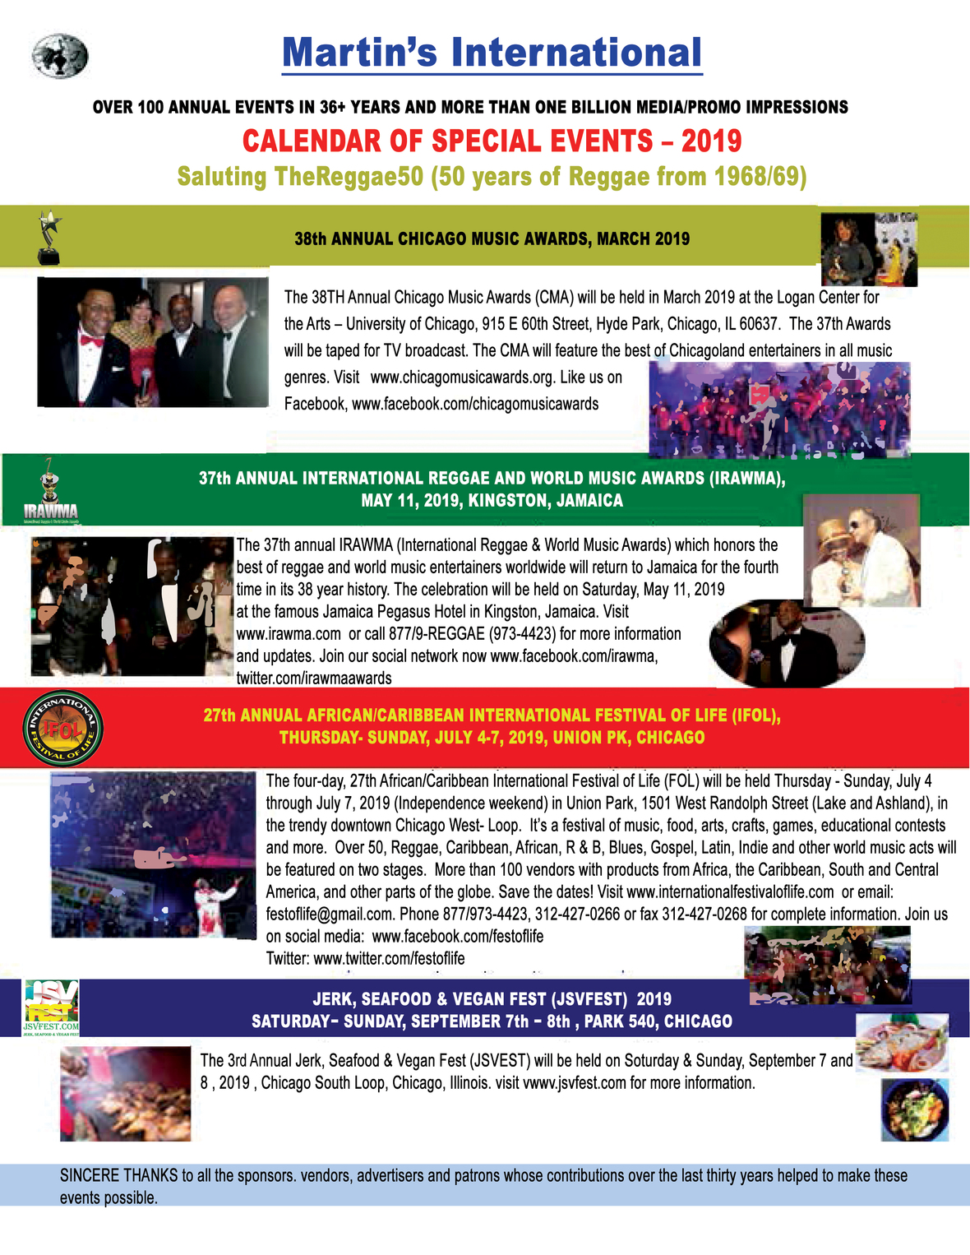

©2018 Martin International | 1325 South Wabash, #307, Chicago, IL. 60605. www.martinsinternational.com

Like Tweet Pin +1 in

Web Version Preferences Forward

Powered by
GoDaddy Email Marketing ®

